

School of Systems and Technology

**Web Technologies**

**Section: Y2**

**Submitted By:**

Name: HAIQA HUMAYUN

ID: F2020105110

**Submission Details:**

Assessment Detail: Class Activity # 2

**Submitted to:**

Instructor: Sir Ali Harris

Page#1

**Code:**

<!DOCTYPE html>

 <html>

 <head>

  <title>Page 1</title>

 <meta charset="utf-8">

  <meta name="viewport" content="width=device-width, initial-scale=1">

  <link href="https://cdn.jsdelivr.net/npm/bootstrap@5.3.0-alpha3/dist/css/bootstrap.min.css" rel="stylesheet" integrity="sha384-KK94CHFLLe+nY2dmCWGMq91rCGa5gtU4mk92HdvYe+M/SXH301p5ILy+dN9+nJOZ" crossorigin="anonymous">

  <style>

.container{

display: grid;

margin: auto;

width: 100%;

text-align: center;

border: 2px solid black;

font-size: 16px;

font-family:  sans-serif;

color:white;

}

.col{

  border: 2px solid black;

}

  </style>

 </head>

 <body>

 <div class="container">

 <div class="row" style="height: 100px;   background-color:rgb(133, 105, 160);" >

  <div class="col"> HEADER </div>

  </div>

  <div class="row"  style="height: 50px;   background-color: rgb(0, 255, 213);">

    <div class="col"> <a href="page2.html" >Home</a></div>

    <div class="col"> <a href="page2.html" >Contact</a> </div>

    <div class="col"> <a href="page2.html" >City</a></div>

    <div class="col"> <a href="page2.html" >Location</a></div>

  </div>

   <div class="row  p-5"  style="height: 400px; column-gap: 7px; ">

     <div class="col" style="background-color: rgb(34, 184, 253);"> Column 1 </div>

     <div class="col" style="background-color: rgb(206, 47, 255); "> Column 2 </div>

     <div class="col" style="background-color: rgb(210, 255, 47); "> Column 3 </div>

   </div>

   <div class="row" style="height: 80px;   background-color: rgb(122, 186, 211);">

    <div class="col"> Footer </div>

    </div>

 </div>

 </body>

 </html>

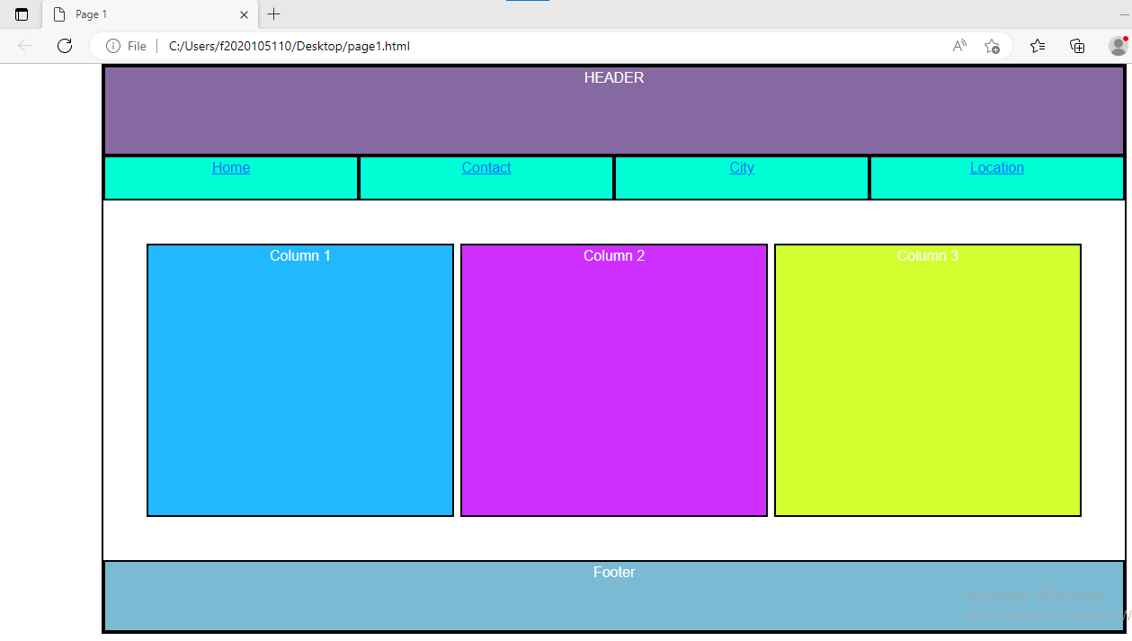

**Page #2**

**Code:**

<!DOCTYPE html>

 <html>

 <head>

  <title>page2</title>

 <meta charset="utf-8">

  <meta name="viewport" content="width=device-width, initial-scale=1">

  <link href="https://cdn.jsdelivr.net/npm/bootstrap@5.3.0-alpha3/dist/css/bootstrap.min.css" rel="stylesheet" integrity="sha384-KK94CHFLLe+nY2dmCWGMq91rCGa5gtU4mk92HdvYe+M/SXH301p5ILy+dN9+nJOZ" crossorigin="anonymous">

  <style>

.container{

display: grid;

margin: auto;

width: 100%;

text-align: center;

border: 2px solid black;

color:white;

}

.col{

  border: 2px solid black;

}

  </style>

 </head>

 <body>

 <div class="container">

 <div class="row" style="height: 100px;   background-color:rgb(142, 97, 184); text-align:center;">

  <div class="col"> HEADER </div>

  </div>

  <div class="row"  style="height: 50px;   background-color: rgb(0, 255, 221);">

    <div class="col"> <a href="page1.html" >Home</a></div>

    <div class="col"> <a href="page1.html" >Contact</a> </div>

    <div class="col"> <a href="page1.html" >City</a></div>

    <div class="col"> <a href="page1.html" >Location</a></div>

  </div>

   <div class="row  p-5"  style="height: 400px; column-gap: 8Spx; ">

 <div class="col-9" style="background-color: rgb(156, 181, 235);"> Column 1 </div>

   <div class="col-2" style="background-color: rgb(177, 221, 241); "> Column 2 </div>

   </div>

 <div class="row" style="height: 80px;   background-color: rgb(205, 228, 175);">

    <div class="col"> Footer </div>

    </div>

 </div>

 </body>

 </html>

**OUTPUT**

